**PRESENTS**

**2025 Junior Sprint**

**State Titles**

**Champion Lakes**

**26th April**

**EVENTS**

**0800 REGOS & SIGN IN.**

**0830 Blessing & race brief.**

**0900 Races begin.**



**Protest forms as per AOCRA, protests are to be made within 15mins of the race.**

**Protest will cost $50. Your race director on the day, Connie Hughes will defer to**

**An established protest committee.**

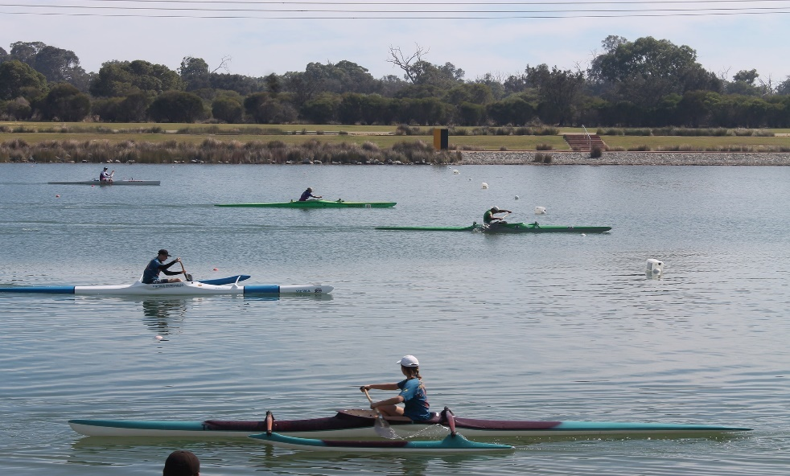



This event will be run under the AOCRA Regatta & Training Rules

**LOCATION**

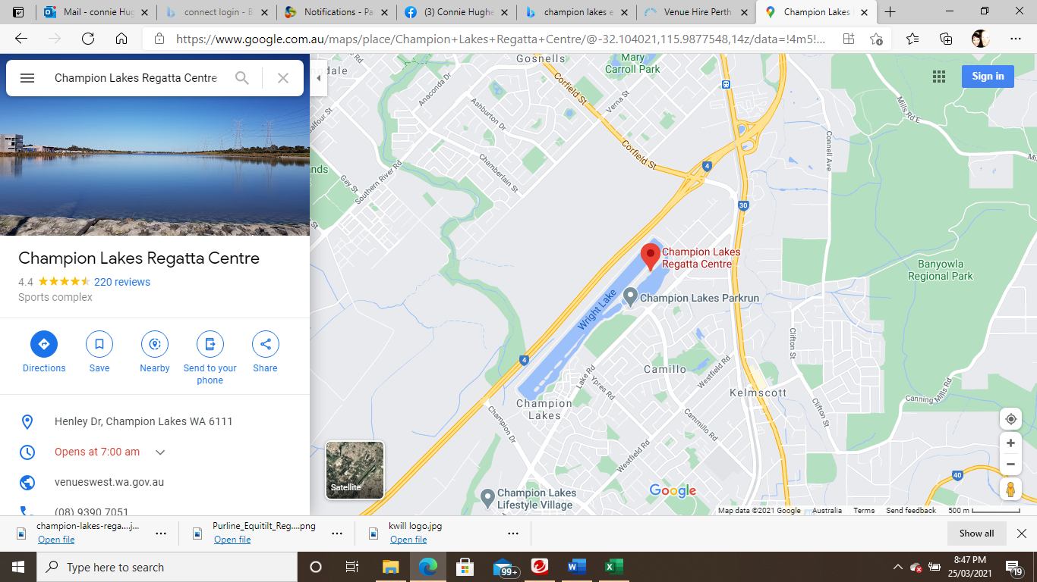

**COST ..........................$25 per paddler**

Registrars, club nomination first, then set your teams first for V6 and V12. If you have Kids without a team, please do them separately to the teams lists and add in notes that they need a team. Put your V1 paddlers into a separate Team list with V1 in notes. Club and Team regos DUE SAT 12 APRIL 25

This is not negotiable, due to the amount of time it takes to enter paddlers and complete the program.

**FOOD etc.**

KVOCC will be selling food and drinks.

Clubs will need shade tents. Please place these 2m back from the path and use weights to secure them. to avoid reticulation under the grass.

**PLEASE BE PUNCTUAL.**

Please arrive at champion lakes on time to sign in.

There will be multiple heats, upwards of 60 races for the day.

So, we need to be prompt when races are called and marshalled. We will be holding two heats in the marshalling area, while one paddles up and one is racing, the heats need to keep moving in order to keep the races flowing and staying within our allotted time frame at champion lakes.

